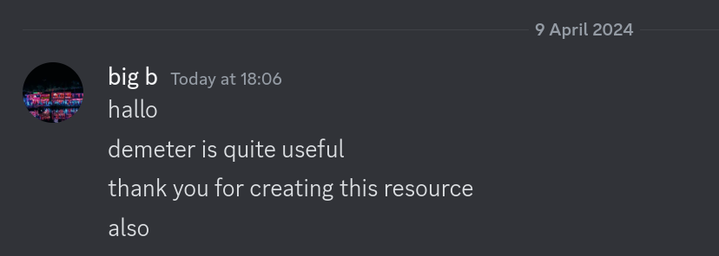Demeter Instructions



# General use

### Basic features

- All data saved on the website can be accessed through the filetree on the left.

- **Left-click** on folders (marked *grey*) to open their contents.

- **Left-click** on files to ‘open’ the file. This means you will be able to mark it as read/review (more on this later), write specific notes for that file, and the file will be loaded in the document viewer.

- **Right-click** on folders to focus in on them. This narrows the context of the filetree, which is useful if you want to only open all read files in a specific folder (more on this later).

### **Advanced features**

At the top-right corner, you may notice a notepad button with a question mark next to it. This is a **notepad** built into Demeter, using [SimpleMDE](https://simplemde.com/). This is a notepad that uses **markdown** as its text type. A guide for markdown can be found by clicking the question mark.

The three boxes above the document viewer contain additional features which may be useful when using Demeter.

#### ***1st box - Main***

This box contains the following checkboxes:

- **Mark as read**: Select this to mark this file as read. This is so you can know that you’ve seen this file before.

- **Mark for review**: Select this to mark this file for review. This is an additional, optional distinction you can make for files which you may want to revisit to look over at a later date.

- **Open all read files**: Select this to open all files which are read. This means that the file directory will now display all files marked as read in the current focus.

- **Open all files for review**: Select this to open all files which are marked for review. This means that the file directory will now display all files marked for review in the current focus.

#### ***2nd box - Clock***

This box contains a clock.

- You have the option to add time to the clock, with the preset options being *+1 hour*, *+30 minutes*, *+10 minutes*, *+5 minutes*, *+1 minute*.

Once you have added time to the clock, you can then press **Start Countdown**, to start the timer. The clock will then countdown from your set time to **00:00:00**. Once this occurs, the timer ends and an alert is displayed. After which, the time elapsed is displayed, which can be copied to the clipboard by pressing the copy button.

You can press **Reset Countdown** at any time to reset any time added to the clock.

While the clock is counting down, you may press **Stop Countdown**. This *pauses the timer* (**Start Countdown** can be pressed to resume), and displays the time elapsed, which can again be copied to the clipboard.

#### ***3rd box – File notes***

When a file is open, the file’s specific file notes can be accessed. These notes are formatted as plain-text. You can type in a file’s file notes, which are automatically saved, and then access them at a later date. This is useful if you want to note down specific things about a file to remember for later.

There is also the **Clear file notes** checkbox, which clear ALL file notes saved locally.

# Saving and loading

### **Saving**

***I suggest frequently(ish) saving your data, in case something disasterous happens in the future.***

Demeter automatically saves the following data in your browser’s local storage:

- **Read files**

- **Review files**

- **File notes**

- **Notepad data**

- Update history (whether you last opened Demeter on an outdated version)

However, in case you accidentally lose all your local storage data, or you want to move to a different main browser, you can take(the majority) of your data with you, specifically the ones in bold above.

- It’s unnecessary to take update history with you. Update history is only used to decide whether a pop-up opens when you open Demeter, which shows the recent updates made.

To save your data, press the **Save data as JSON** button. This downloads a **.json** file to your computer.

### **Loading**

Once you’ve saved your data from a prior session as a **.json** file, you can then upload it to Demeter by pressing **Choose file**, next to the “Load JSON file” heading. Please note that **this will overwrite any existing data**, so be careful!

Please note that you should only load data from a **.json** file when its the same data present on the website. Otherwise, Demeter is likely to break.